**Biology STAAR Review Activities**

**Day 1**

**Category #1 Cell Structure and Processes (4.A, 4.B, 4.C)**

4.A compare and contrast prokaryotic and eukaryotic cells;

4.B investigate and explain cellular processes, including homeostasis, energy conversions, transport of molecules, and synthesis of new molecules

4.C compare the structures of viruses to cells, describe viral reproduction and describe the role of viruses in causing diseases such as human immunodeficiency virus (HIV) and influenza.

**4.A, 4.B, 4.C Pre-Test Score_________ Focus TEKS_________________________**

|  |  |  |  |
| --- | --- | --- | --- |
|  | **4.A** | **4.B** | **4.C** |
| **Interactive Quizzes** | **Structures and Organelles**  <http://glencoe.mcgraw-hill.com/sites/0078802849/student_view0/unit2/chapter7/section3/self-check_quizzes-english.html> | **Cellular Transport**  <http://glencoe.mcgraw-hill.com/sites/0078802849/student_view0/unit2/chapter7/section4/self-check_quizzes-english.html> | **Viruses and Bacteria**  <http://www.braingle.com/trivia/17880/viruses-and-bacteria.html> |
| **Prokaryote vs. Eukaryote**  <http://www.proprofs.com/quiz-school/quizshow.php?title=prokaryotic-vs-eukaryotic-cells&q=6&next=n&sid=60489514> |
| **Graphic Organizers** | Create a Venn Diagram comparing prokaryotic and eukaryotic cells.  See handout below | **Cell Processes Matching-Match up titles to the appropriate descriptions of cell processes.**  [**http://www.biologycorner.com/worksheets/cell_membrane_images.html**](http://www.biologycorner.com/worksheets/cell_membrane_images.html) | **Make a graphic organizer that compares the structures of a virus and of a cell.**  **See handout below** |
| **Virtual Labs** | **Under What Conditions Do Cells Gain or Lose Water?**  [**http://www.glencoe.com/sites/common_assets/science/virtual_labs/LS03/LS03.html**](http://www.glencoe.com/sites/common_assets/science/virtual_labs/LS03/LS03.html) | **Osmosis and Diffusion**  [**http://content.bfwpub.com/webroot_pubcontent/Content/BCS_4/Bres1e/Activities/Exercise_5-Activity_3/resources/e5a3.html**](http://content.bfwpub.com/webroot_pubcontent/Content/BCS_4/Bres1e/Activities/Exercise_5-Activity_3/resources/e5a3.html)  **Diffusion and Osmosis**  [**http://content.bfwpub.com/webroot_pubcontent/Content/BCS_4/Bres1e/Activities/Exercise_5-Activity_3a/Diffusion.html**](http://content.bfwpub.com/webroot_pubcontent/Content/BCS_4/Bres1e/Activities/Exercise_5-Activity_3a/Diffusion.html) | **Making Vaccines**  [**http://www.pbs.org/wgbh/nova/bioterror/vaccines.html**](http://www.pbs.org/wgbh/nova/bioterror/vaccines.html) |
| **Vocabulary** | **Cell Structure and Function Flashcards**  <http://quizlet.com/172368/chapter-7-cell-structure-and-function-flash-cards/> | | **Viruses**  <http://quizlet.com/35592660/viruses-flash-cards/> |
| **Video Clips** | **Prokaryotic and Eukaryotic Cell Video**  <http://www.youtube.com/watch?v=ruBAHiij4EA> | **Membranes and Transport Video**  <https://www.youtube.com/watch?v=dPKvHrD1eS4&edufilter=_2nXFUMaB1_cnY78uKT5qQ> | **Viruses**  <http://www.wimp.com/virusinvades/> |

**4.A, 4.B, 4.C Post-Test Score_________**

**Notes:**

**4.A, 4.B, 4.C Critical Thinking Questions**

1. What are the differences and similarities between prokaryotic and eukaryotic cells?

2. How does the structure of the cell membrane relate to it’s function?

3. How can you evaluate the movement of molecules across a biological membrane?

4. Discuss how a cell maintains homeostasis.

5. How does virus structure relate to function?

6. Explain how viruses reproduce.

7. Describe how some diseases are caused by viruses

**4.A Graphic Organizer**

Create a Venn Diagram comparing prokaryotic and eukaryotic cells. Include the following terms:

Eukaryotic Cells

Prokaryotic Cells

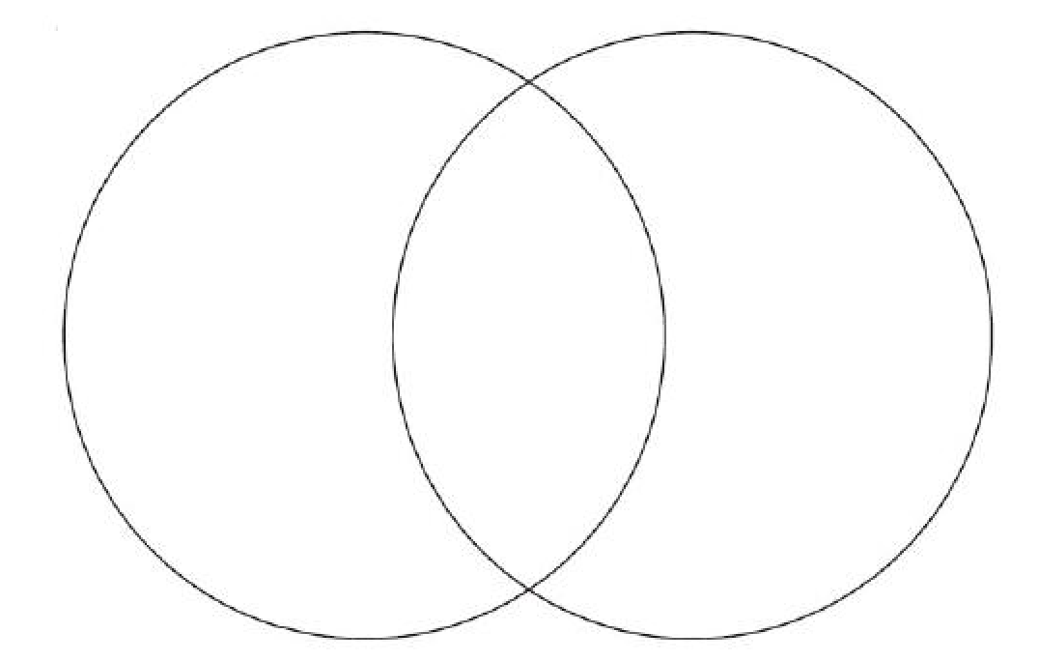

Word Bank

nucleic acids, nucleus, DNA, nuclear membrane, Cell membrane, Membrane bound organelles, Ribosomes, Mitosis, Binary Fission,

Large, Small, RNA, Regulate the flow of nutrients and waste

Helpful links:

<http://www.invive.com/cells.html>

<http://etap.org/demo/biology1/instruction3tutor.html>

**4.C Graphic Organizer**

|  |  |  |
| --- | --- | --- |
| **Viruses and Cells** | | |
| **Characteristic** | **Virus** | **Cell** |
| Structure | **DNA or RNA in capsid** |  |
| Reproduction |  | **Divides on own; asexually or sexually** |
| Genetic Code |  | **DNA** |
| Growth and Development | **No** |  |
| Obtain and Use Energy |  | **Yes** |
| Response to Environment | **No** |  |
| Change Over Time | **Yes** |  |

**Day One Review Questions (4.A, 4.B, 4.C)**

4.A

_____1. The major difference between prokaryotes and eukaryotes is the presence or absence of the following:

a. cytoplasm

b. membrane-bound organelles

c. golgi bodies

d. nucleic acids

4.A

_____2. Which of the following is found only in eukayrotes?

a. cell membrane

b. DNA

c. cytoplasm

d. mitochondria

4.A

_____3. Miguel is looking at cells through a microscope. His teacher, Mrs. Sheng, has told him that he is viewing either a tomato cell or a bacterial cell. Mrs. Sheng would like Miguel to answer some questions about the cell he is looking at. Mrs. Sheng asks Miguel to figure out what type of cell he is viewing. What cell structure should Miguel be looking for to determine whether this cell came from a tomato plant or a bacterium?

a. ribosomes

b. mitochondria

c. nucleus

d. DNA

4.A

_____4. Which cell organelle manages the process by which worn out organelles, food particles, and engulfed viruses or bacteria are digested?

a. ribosomes

b. lysosomes

c. vacuoles

d. golgi bodies

4.B

_____5. While cleaning a saltwater aquarium, students placed the aquarium plants in distilled water. What effect will this have on the plants?

a. The plants will shrink

b. There will be no effect on the plants

c. The plants will swell

d. The plants will separate

4.B

_____6. A plant has been removed from its natural environment and placed in an environment that contains more salt than found on the inside of the plant cell. This situation is similar to which of the following events?

a. a sea plant put in distilled water

b. a sea plant put in fresh water

c. a freshwater plant put in sea water

d. a land plant put in tap water

4.B

_____7. Homeostasis is the condition in which the body maintains:

1. the lowest possible energy usage
2. a relatively stable internal environment, within limits
3. a static state with no deviation from present points
4. a changing state, within an unlimited range

4.B

_____8. The two body systems that regulate homeostasis are the:

a. cardiovascular and respiratory systems  
b. cardiovascular and urinary systems  
c. nervous and cardiovascular systems  
d. nervous and endocrine systems

**4.B Score______________/4**

|  |  |
| --- | --- |
| Viral Disease | Common Method of Transmission |
| Smallpox | Direct Contact |
| Influenza | Airborne droplets |
| AIDS | Exchange of body fluids |
| West Nile | Mosquitos |

4.C

_____9. According the above table, viruses can be transmitted in a variety of ways. This SARS (severe acute respiratory syndrome) can be transmitted when an infected person coughs or sneezes. SARS is transferred similarly to what other virus listed on the table?

1. smallpox
2. influenza
3. AIDS
4. West Nile

4.C

_____10. Vaccines can be used to prevent viral infection by:  
 a. creating an immune response in the host  
 b. destroying any viruses that enter the host  
 c. creating a blocking protein on the cell  
 d. preventing replication of the virus

4.C

_____11. What happens after the virus has been taken up by the cell?  
 a. it begins making protein   
 b. it divides  
 c. it inserts into the host DNA  
 d. it switches to infectious mode

4.C

_____12.Viruses require __________ for growth.

a. bacteria

b. plants

c. animals

d. living cells

**4.C Score______________/4**

**Day One Review Questions (4.A, 4.B, 4.C)**

**Answer Sheet**

**_____1.**

**_____2.**

**_____3.**

**_____4.**

**4.A Score______________/4**

**_____5.**

**_____6.**

**_____7.**

**_____8.**

**4.B Score______________/4**

**_____9.**

**_____10.**

**_____11.**

**_____12.**

**4.C Score______________/4**

**Focus TEKS:**

**Day One Review Questions (4.A, 4.B, 4.C)-Key**

**__B__1.**

**__D__2.**

**__C__3.**

**__B__4.**

**__C__5.**

**__C 6.**

**__B__7.**

**__D__8.**

**__B__9.**

**__A__10.**

**__C__11.**

**__D__12.**